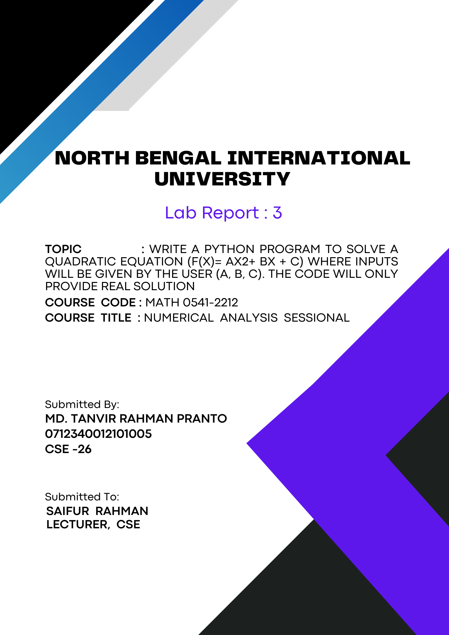
1

Write a python program to solve a quadratic equation (f(x)= ax2+ bx + c) where inputs will be given by the user (a, b, c). The code will only provide real solution:

Theory: Theory of Solving a Quadratic Equation Using Python

A quadratic equation takes the form ax^2 + bx + c = 0, where a, b, and c are coefficients provided by the user. Solving such an equation involves finding the roots (values of x) where the equation equals zero. The program leverages Python's capabilities to handle these calculations and provide real solutions.
Steps:
1. Input Handling: The program prompts the user to input the coefficients a, b, and c. These inputs are converted to floating-point numbers to ensure precision in calculations.

2. Discriminant Calculation: The discriminant (Δ) is calculated using the formula Δ = b^2 - 4ac. The discriminant determines the nature of the roots:
- If Δ > 0, there are two distinct real roots.
- If Δ = 0, there is one real root.
- If Δ < 0, the equation has no real solutions.

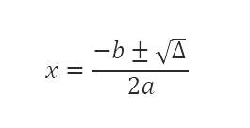
3. Root Calculation: For non-negative discriminants, the program computes the roots using the quadratic formula:

Here, √Δ represents the square root of the discriminant, and the ± symbol indicates the two possible solutions.

4. Output: The calculated roots are printed as the solutions. If the discriminant is negative, the program informs the user that no real solutions exist.

Algorithm:

1. Start.
2. Get the numbers:
- Ask the user to enter the values for a, b, and c.
3. Calculate a special number:
- Find the discriminant using the formula b^2 - 4ac. This special number helps us decide if there are real solutions.
4. Check the special number:
- If this number is not negative (0 or more):
- Go to step 5.
- If this number is negative:
- Print "The equation has no real solutions".
- Go to step 8.
5. Find the solutions:
- Use two formulas to get the answers (roots):
- First solution: (-b + sqrt(discriminant)) / (2a).
- Second solution: (-b - sqrt(discriminant)) / (2a).
6. Show the solutions:
- Print both solutions.
7. End.

Code:

import math

# Input coefficients from the user
a = float(input("Enter coefficient a: "))
b = float(input("Enter coefficient b: "))
c = float(input("Enter coefficient c: "))

# Calculate the discriminant
discriminant = b**2 - 4*a*c

# Check if the discriminant is non-negative
if discriminant >= 0:
# Calculate the two solutions
root1 = (-b + math.sqrt(discriminant)) / (2 * a)
root2 = (-b - math.sqrt(discriminant)) / (2 * a)
print(f"The solutions are {root1} and {root2}")
else:
print("The equation has no real solutions")

Output:

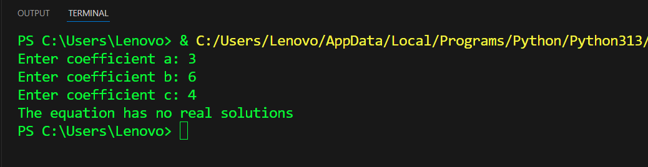

Conclusion: In conclusion, the program solves a quadratic equation by taking user input for the coefficients, calculating the discriminant, and finding the roots if real solutions exist. It demonstrates basic programming concepts like input handling, conditionals, and mathematical computations in Python.

